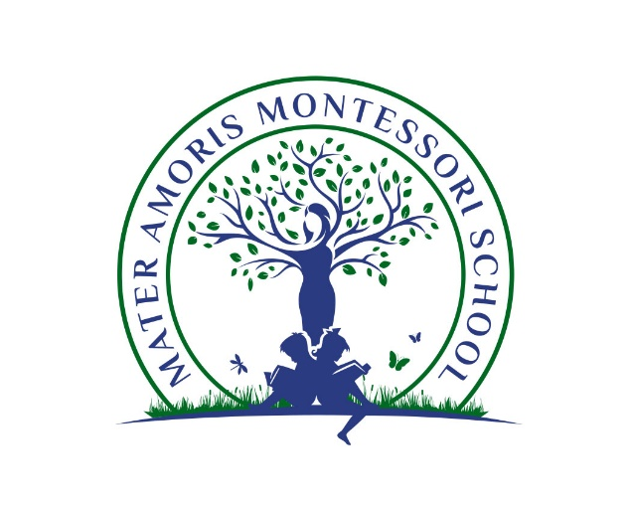
Mater Amoris Montessori School is a non-profit corporation governed by the Board of Trustees of the Montessori Society of Ashton, Inc. Mater Amoris adheres to the guidelines established by the Association Montessori Internationale (AMI) and dedicates itself to the philosophy of Dr. Maria Montessori in the belief that her teachings provide a scientifically-based system that helps the child not only during early development, but throughout life. Mater Amoris Montessori School is dedicated to the development of each child according to his/her specific needs and interests.
Mater Amoris is in search of an assistant to support a lead guide in an early childhood classroom, ages 2-6.
The role of an assistant is to support the lead guide in establishing and maintaining a harmonious classroom. The assistant supports students in their academic, social, emotional, and physical development in accordance with Montessori philosophy. Candidates must be hard working, adaptable, team players, and flexible thinkers, who are eager to be fully engaged in this exciting opportunity.
A successful candidate should possess, at minimum, a high school diploma and have at least one year of experience working with children. They should demonstrate an ability to work as part of a dynamic and diverse team and be willing to comply with all continuing education requirements.
Interested individuals should email a cover letter, resume, and list of references to jobs@materamoris.org.

