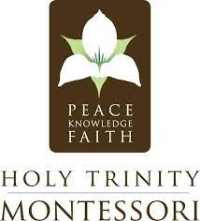

Holy Trinity Montessori
Job Descriptions

Title: Lead Teacher for Upper Elementary Classroom (ages 9-12 year olds)

Description:
West Nashville Montessori school located on a beautiful, pristine, 37-acre campus, seeking a lower elementary lead teacher exhibiting strong co-teaching capabilities and a love for working with children ages 9-12 in a Montessori environment. Applicants need experience working with children and willing to be a member of a hard-working faculty and team. Lead teacher is responsible for leading the classroom, managing of lesson plans, and communicating with parents. Applicants must exhibit strong communication skills and an excitement for teaching.

Position: Full-Time Lead Teacher
Start Date: August 2025

Qualifications & Experience:
- Bachelor’s degree in Early Childhood/Child Development or equivalent
- Montessori certification (preferred)

Expectations:
- Full responsibility of classroom operations, communications, and overall leadership while planning and running a clean and efficient classroom up to Montessori standards
- Have a child-first mindset that promotes the healthy emotional, social, intellectual, and physical development of each child working within a three-year cycle
- Maintain prompt hours and a cooperative and professional work relationship with others, attend all staff meetings, in-services, trainings, parent-teacher conferences, and school events
- Communicate with parents, teachers, staff, and administration both in person and through the school’s online platform

Send Inquiries To: kate.riley@holytrinitymontessori.org

Take a Look at Our School: www.holytrinitymontessori.org

